**Docker Tutorial**

**What is Docker ?**

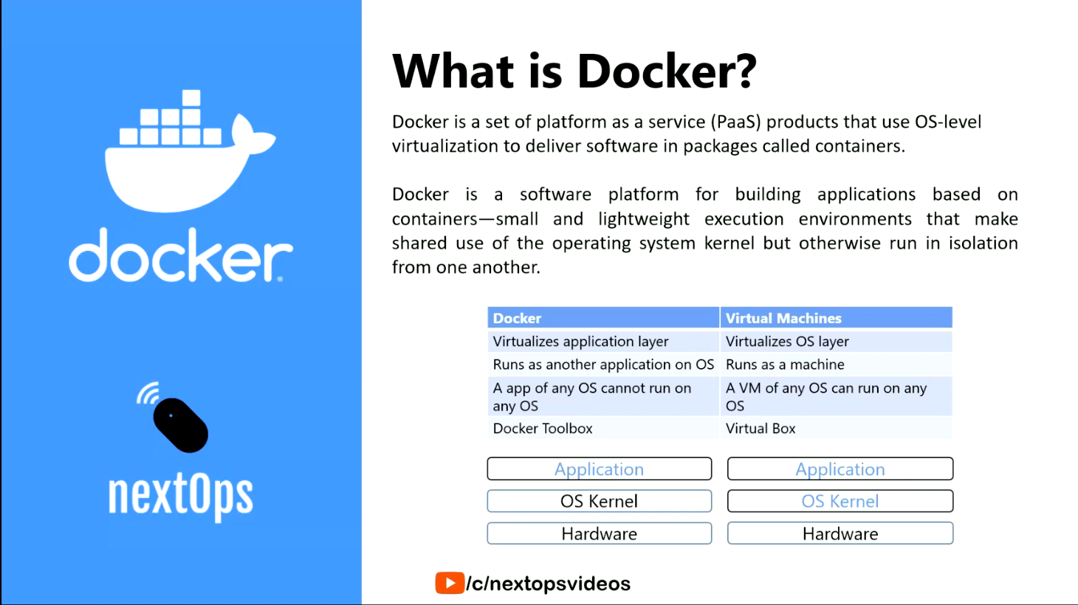

**Before Docker ?**

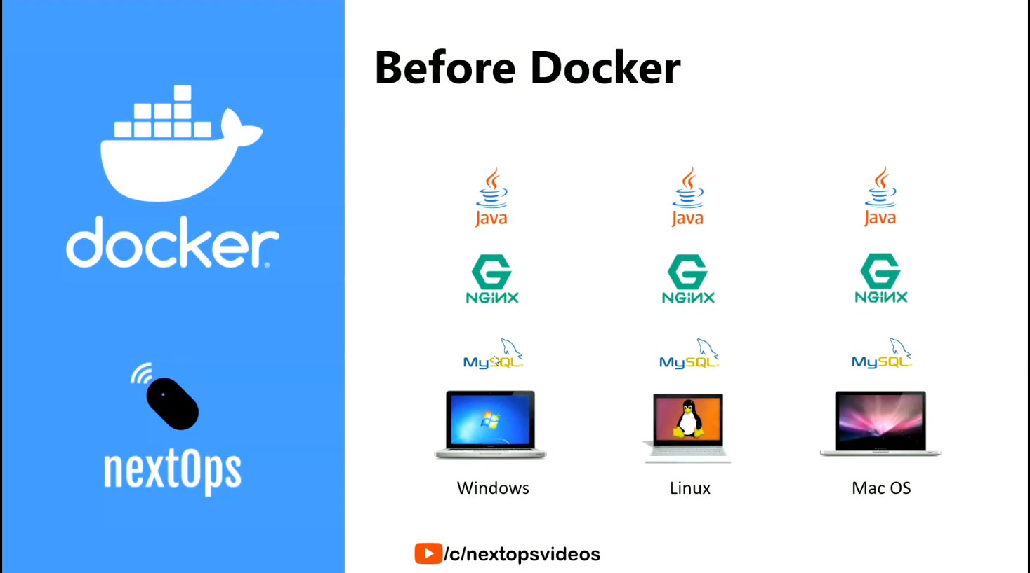

**After Docker ?**

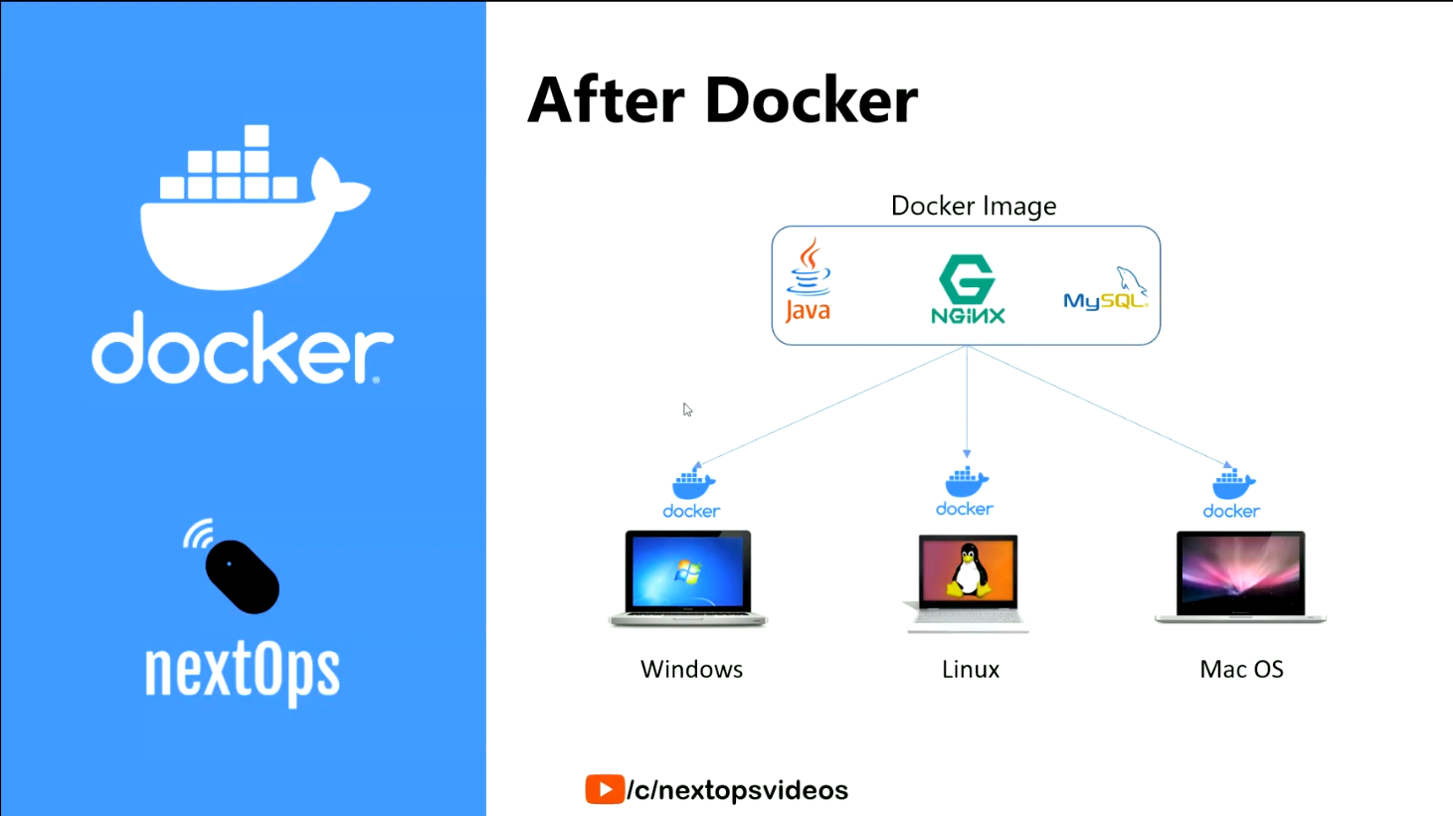

**What is A Container ?**

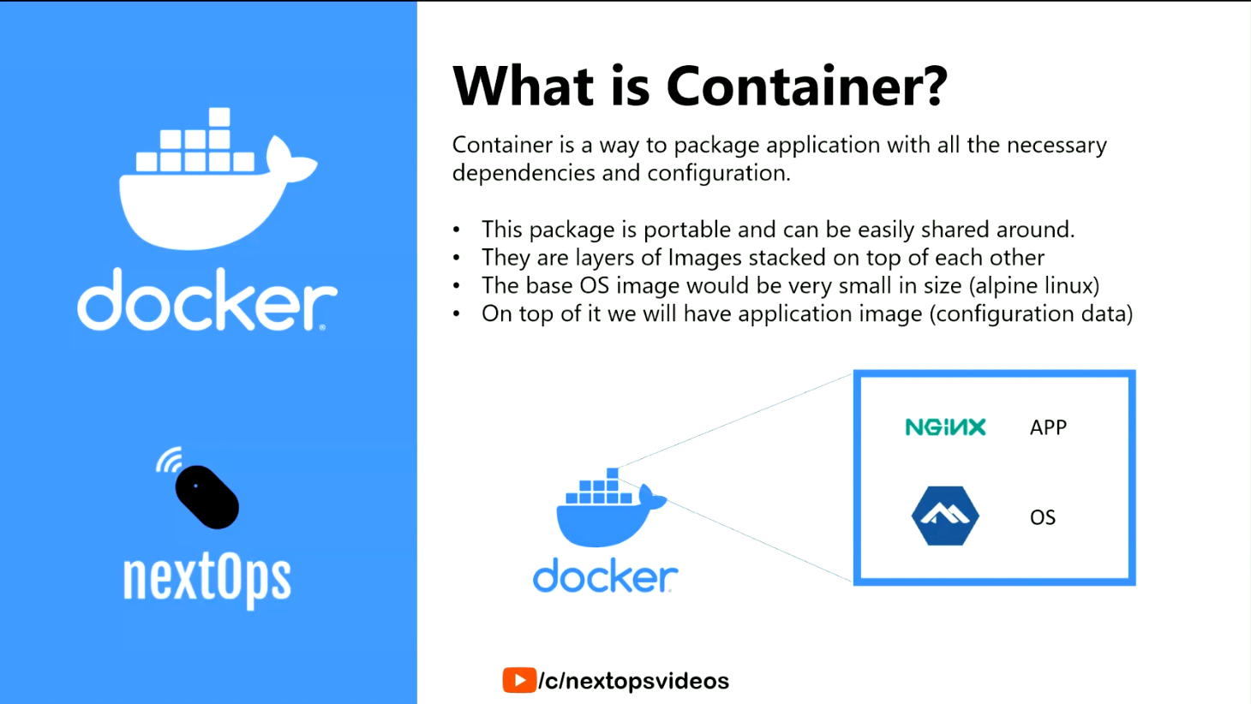

**What is Docker Image ?**

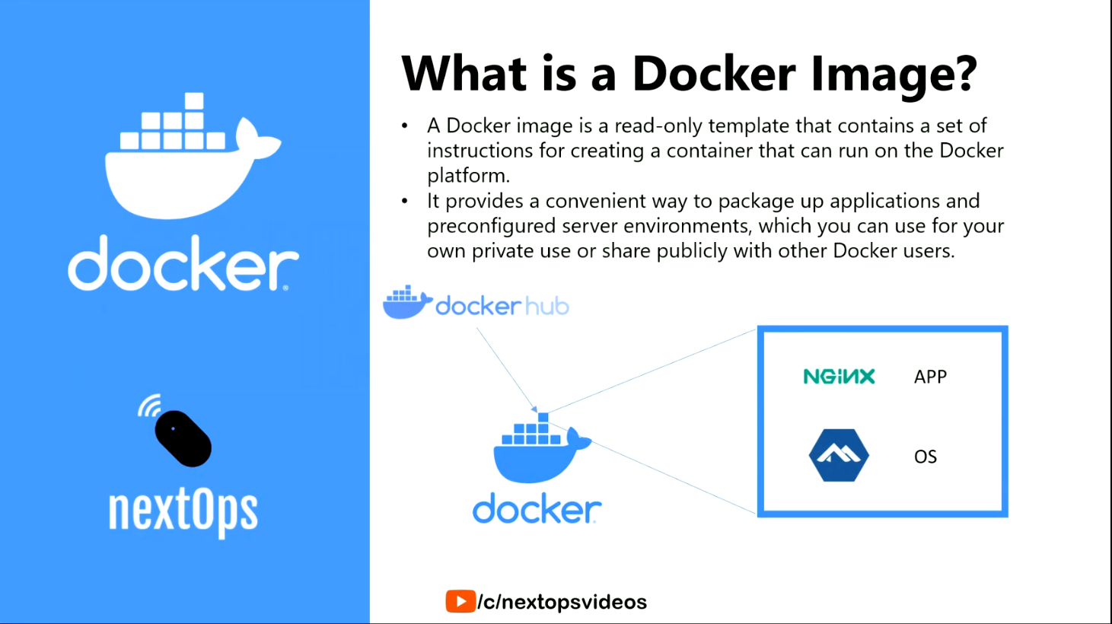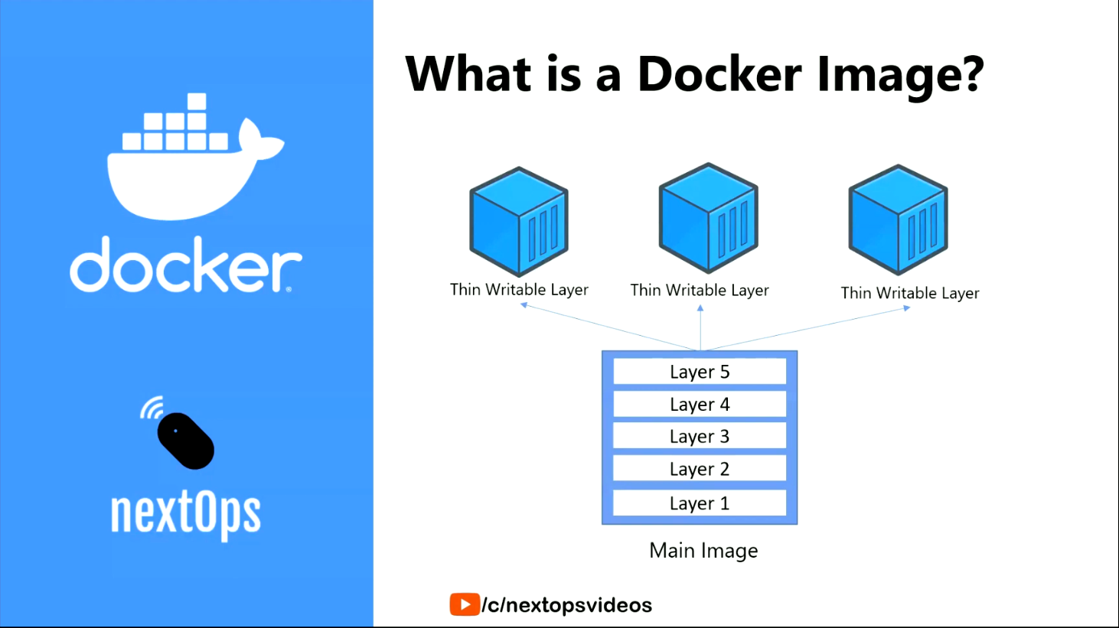

**Above writable layers are temporary storage layers .. when the container is start,that time writable layers will created..when the container is stoped , writable layers also delete..**

**From one image we can create n number of containers**

**Docker Image Commands**

**Pull image from docker hub :**

**It will takes automatically latest version only**

**Cmd : docker pull image_name**

**Pull specific image from docker hub :**

**It will takes automatically latest version only**

**Cmd : docker pull image_name:version**

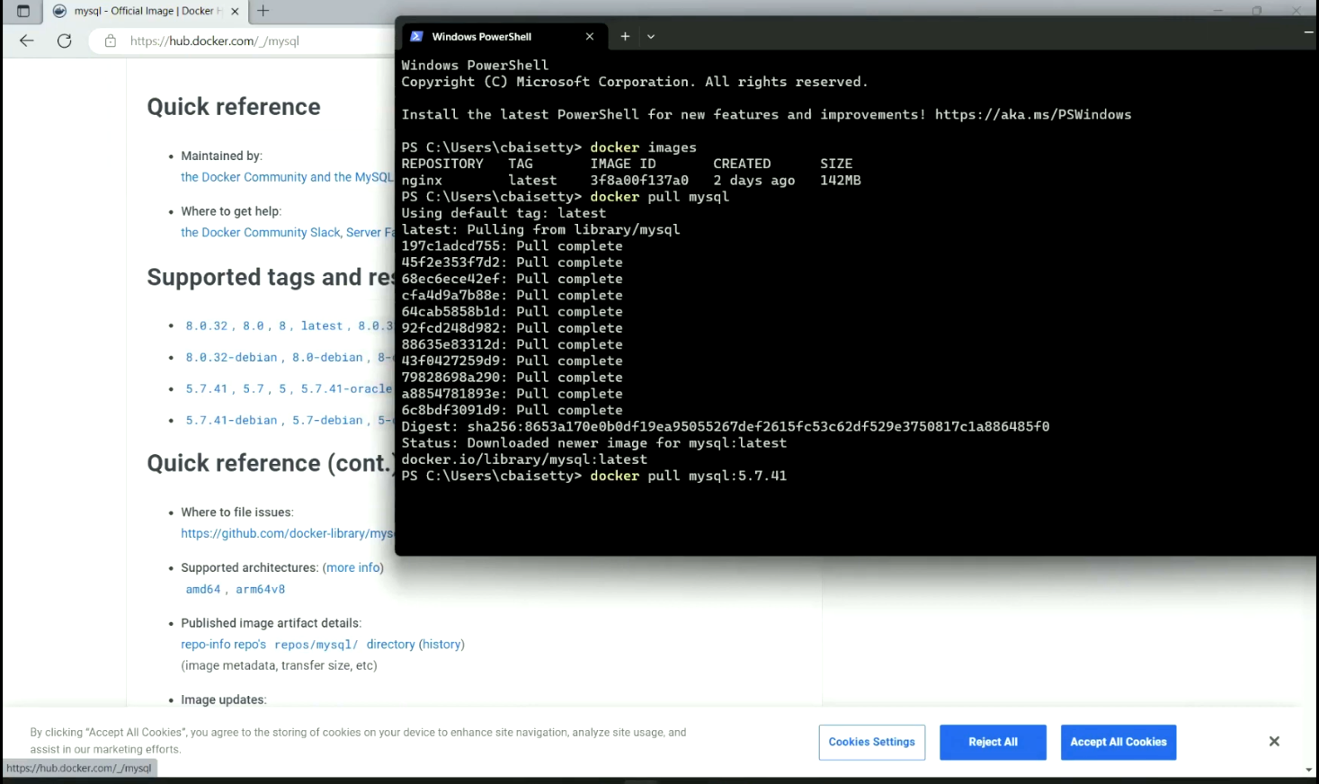

**get image history :**

**Cmd : docker history image_name**

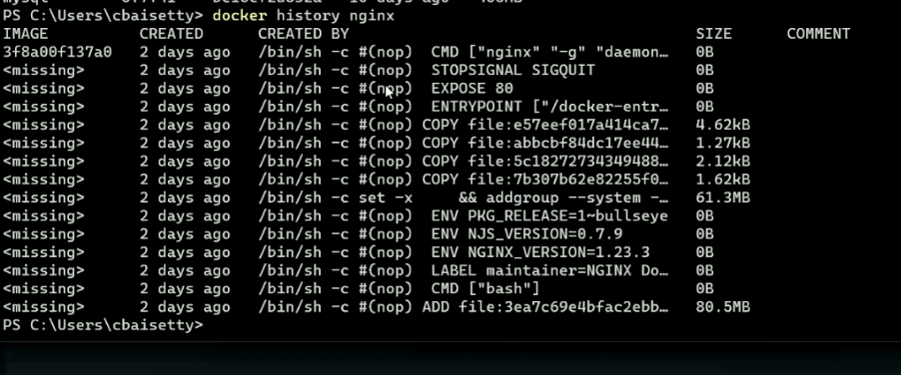

**remove specific image:**

**It will takes automatically latest version only**

**Cmd : docker rmi image_name**

**Cmd : docker rmi image_name:10.20.78**

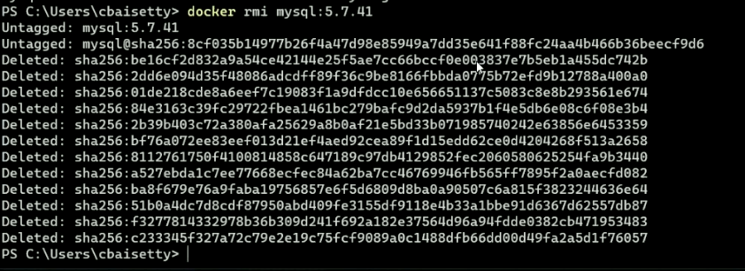

**Docker Basic Commands**

**Login**

**Cmd : docker login**

**Logout**

**Cmd : docker logout**

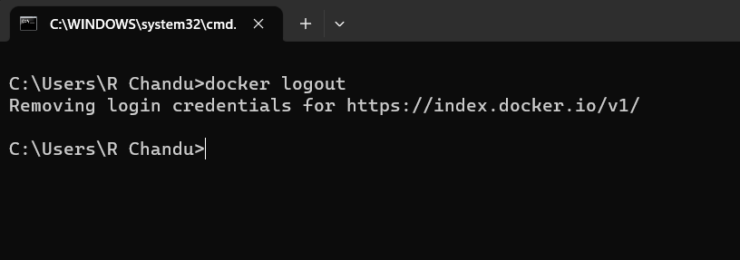

**Docker search images**

**Cmd : docker search image_name**

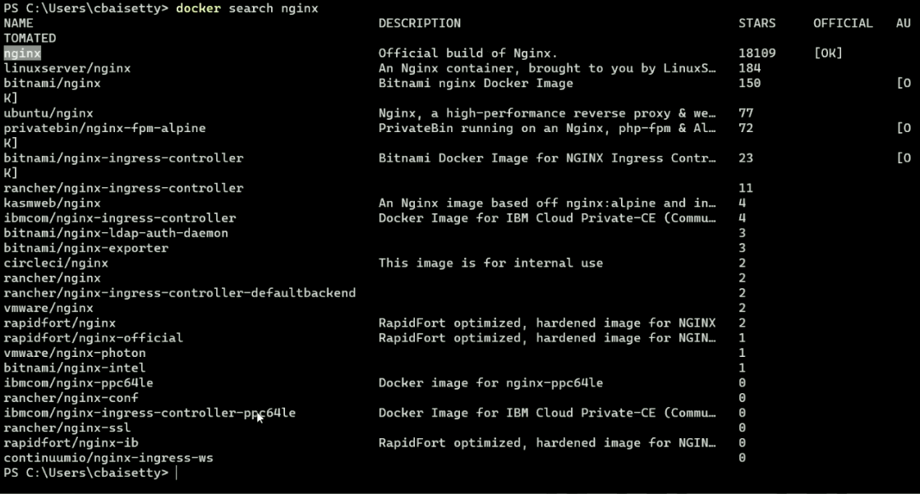

**Docker inspect**

**Cmd : docker inspect image image_name**

**It gives all information about the image**

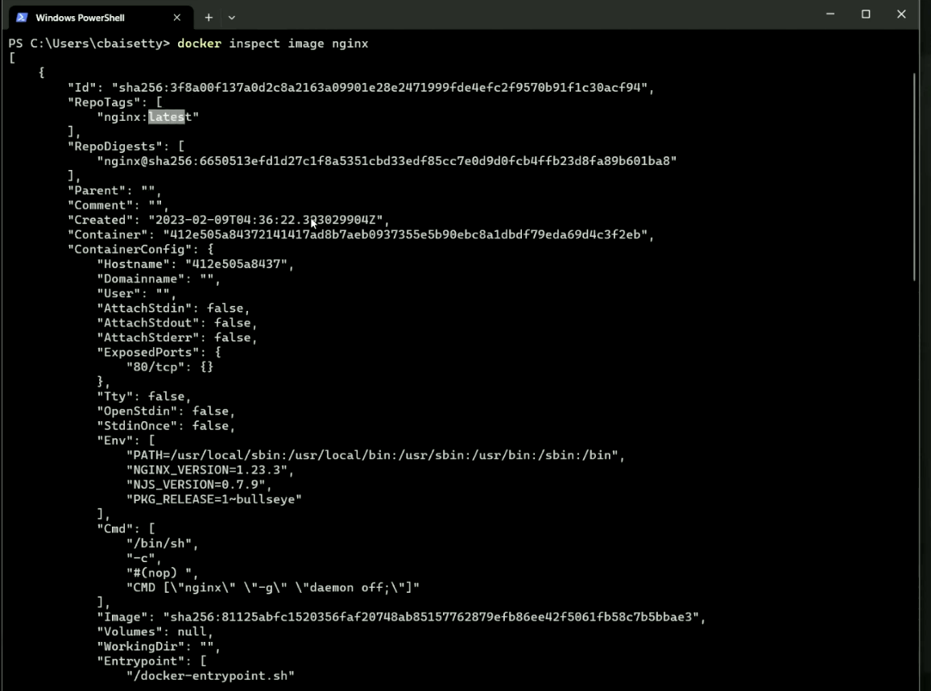

**Container Commands**

**Create,stop a container using image**

**Cmd :Docker create,stop image_name**

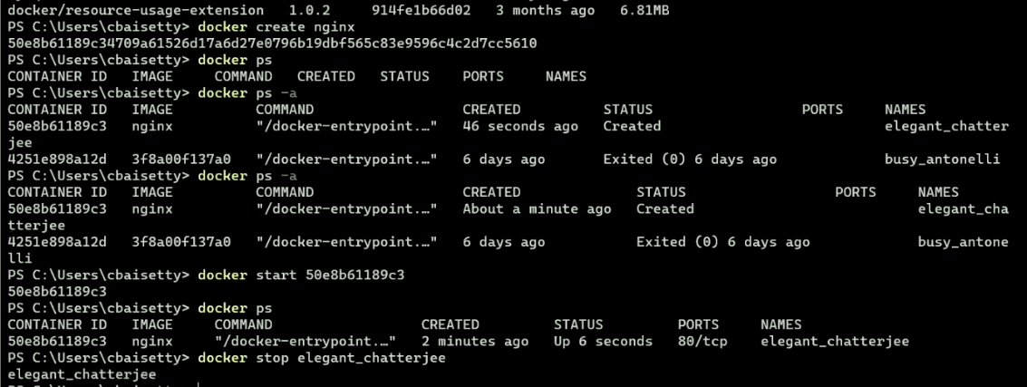

**For stopping the container we can use container id or container name**

**Create, Stop a container using own name**

**Cmd :docker start own_name**

**Cmd : docker stop container_name**

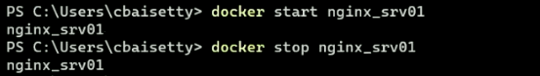

**All in one command for container**

**Cmd :docker run –name own_container_name image_name** 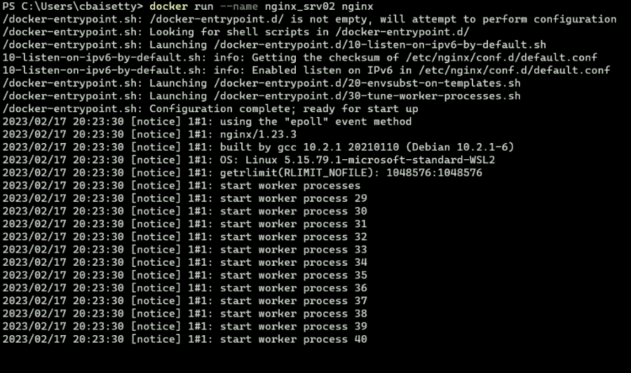

**This will create s the container and starts in terminal..we can see whats happening the container**

**All in one command for container detach mode**

**Cmd : docker run –d –name own_c_name img_name**



**This command creates and run the container, but it will exists in the terminal, container will run in background**

**kill container**

**Cmd : docker kill container_name**

**This command forcefully stops the container , incase stop command didn’t work**

**delete container**

**Cmd : docker rm container_name**

**Login to container terminal**

**Cmd : docker exec –it conta_name /bin/bash**

**This command forcefully stops the container , incase stop command didn’t work**

**Networking**

